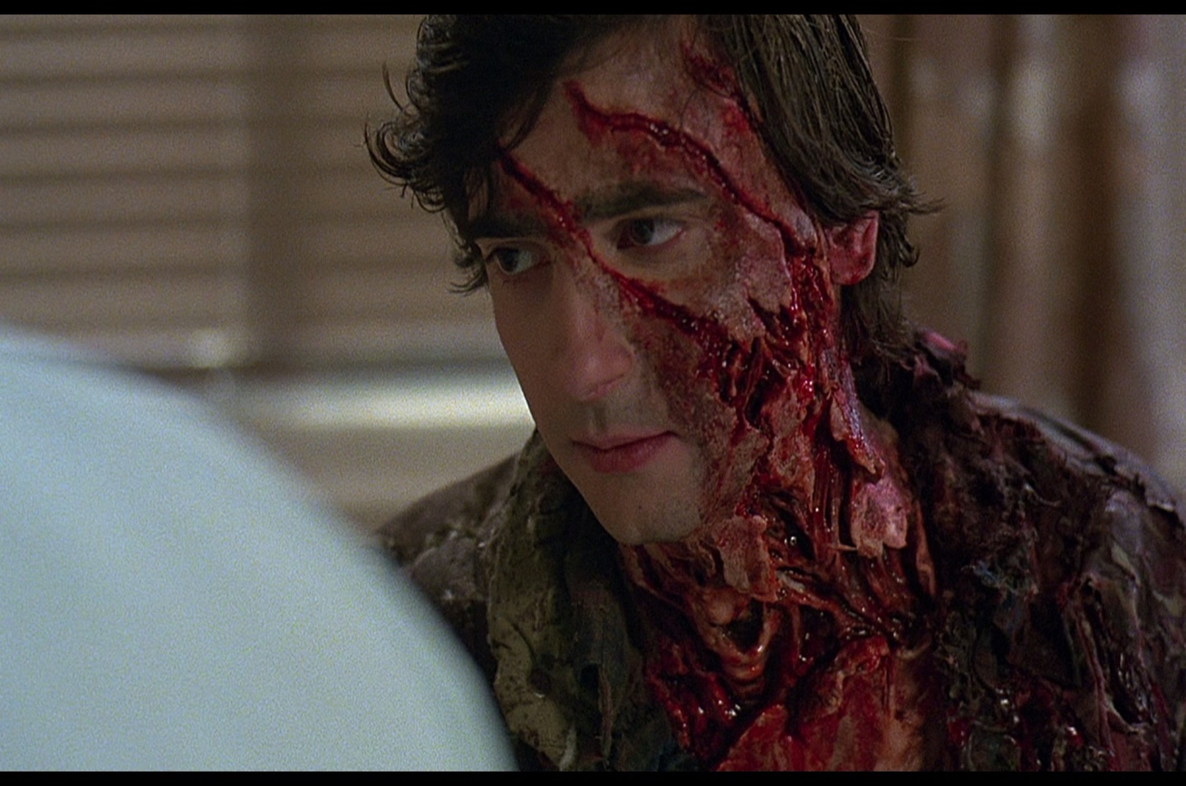
- Hey! I‘m Moreno. I’m 13. I play basketball, but I’m not very good in it. I’m interested in things that most of other kids are scared like horror movies and books, bloody things, slimy and disgusting things... I live with my mother in Velika Mlaka. I’m not really hard-working. I haven’t go any brothers or sisters. My mom works in jewelry store. I have dog. His name is Bolt. My favorite videogame is „God of war“ because i really like Greek myths. If i would have any special powers it would be teleporting.my favorite book is „Vampire diaries“ and „Black dagger brotherhood“ My favorite colour is black. My favorite subjects are English and Biology. My favorite movie is Step up 4 and my favorite series is The Big Bang Theory. Things i'm scared off are brutal horrors with puppets like „Strangers“.

